Using Threads in Java
1. Extend the Thread class:
class MyThread extends Thread {
/** Thread will invoke the run() method */
public void run() {
System.out.println("thread is running");
}
}
2. Create a Runnable and encapsulate in Thread
class Runner implements Runnable {
/** only required method is run */
public void run() {
System.out.println("thread is running");
}
}

Starting a Thread
When an application starts a thread, execution of the first thread continues immediately. The child thread executes asynchronously from the parent.
Case 1: An object that extends Thread.
Thread th = new MyThread( );
th.start( );
System.out.println("done starting thread");
Case 2: An object that implements Runnable.
Runnable runner = new Runner( );
Thread th = new Thread( runner );
th.start( );
System.out.println("done starting runner");

Interrupts
One thread can interrupt another one. But, the thread that receives the interruption must notice and respond to the interrupt. This can happen two ways:
1. thread calls a method that throws IntteruptedException. For example:
public void run() {
try {
Thread.sleep( 5000 ); // 5 seconds
} catch(InteruptedException ex) {
return;
}
}
2. thread invokes interrupted method to test if interrupt flag is set.
while( it.hasNext( ) ) {
Task task = it.next( );
task.perform( ;
// was there an interrupt while we were working?
if ( Thread.interrupted() ) return;
}
For multi-threaded applications that perform long-running tasks, the threads should check intterupted( ) occasionally for the application to be responsive.

Thread Specific Interrupts
Thread.interrupted( ) is a static method. There is also an instance method that a Thread can use to test if it alone has been interrupted:
// which thread object am I?
Thread me = Thread.currentThread( );
if ( ms.isInterupted() ) return;

Waiting for Another Thread to Complete
To wait for another thread to finish, use join().
Thread reader = new ReaderThread( );
reader.start( );
// wait for reader to finish
reader.join( );
join is overloaded. You can specify a maximum length of time to wait for the thread.

Thread Groups
If you have several threads doing tasks related to a single job, you can put them in a ThreadGroup. This makes it easy to monitor and control the entire group of threads.
ThreadGroup tgroup = new ThreadGroup( );
Runnable task1 = new Task( );
Thread thread1 = new Thread( tgroup, task1 );
// give the thread a name: new Thread( tgroup, task1, "Task 1" );
thread1.start( );

Now we can wait for all threads in the group to finish:
while ( tgroup.activeCount() > 0 ) {
try {
Thread.sleep( 1000 );
} catch (InterruptedException ex) } {
// interrupt all the threads
tgroup.interrupt( ); break;
}
}

Example: Competing Threads
Create an application with 2 threads and a Counter object.
- The Counter stores some value. We will use an "int count".
- An Adder thread increments (+1) the counter for a specified number of times.
- A Subtracter thread decrements (-1) the counter for the same number of times.
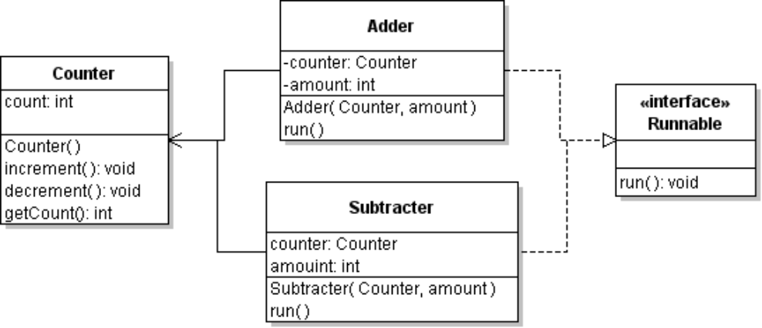
For example, the Adder looks like this:
public class Adder implements Runnable {
private Counter counter;
private final int amount;
/**
* Add amount to a counter, one by one.
* @param counter the counter to use
* @param amount the amount to add
*/
public Adder(Counter counter, int amount) {
this.counter = counter;
this.amount = amount;
}

public void run() {
Thread me = Thread.currentThread();
long id = me.getId();
System.out.printf("Running thread id %d\n", id);
int n = amount;
while (n-- > 0) {
counter.increment();
}
}
}
A Main class creates and starts the threads, then waits for them to finish:
public static void count( int amount ) {
Counter counter = new Counter();
System.out.printf("counter = %d\n", counter.getCount());

int amount = 10000;
Adder add = new Adder(counter, amount);
Subtracter sub = new Subtracter(counter, amount);
Thread t1 = new Thread(add);
Thread t2 = new Thread(sub);
t1.start();
t2.start();

// wait for threads to finish
try {
t1.join();
t2.join();
} catch (InterruptedException ex) {
ex.printStackTrace();
}
System.out.printf("counter = %d\n", counter.getCount());
}

Surround this code with a timer so we can see how long it takes to execute. Use System.nanoTime().

1. Inspect the source code. What should be the final count?
2. Run the application. What is the actual count?
3. Maybe the problem is that the count attribute is being cached in a register, so one thread is getting a stale value. Declare it to be "volatile". Does this fix the problem?
4. Maybe the threads are too greedy. Remove "volatile" from Counter. In the while(n-->0) loop of the Adder and Subtracter, yield the CPU to other thread. Does this fix it?
me.yield( );
5. Remove the yield() statement. Instead declare the Counter's increment and decrement methods to be synchronized. Run again. What affects does this have?
6. Synchronizing an entire method can be inefficient or even cause deadlock. An alternative is to synchronize only the critical block of code using a monitor object (any object). In Counter, synchronize the critical code using the counter itself as a lock object:
synchronized( this ) { // synchronized block
count++;
}
7. As mentioned in the textbook, CPUs often support atomic "get and update" instructions. Java has several Atomic data types that (somehow) provide this behavior.
In the Counter class, change count from "int" to AtomicInteger. Also remove any "synchonized" directives from your code.
You can't write "count++" for an AtomicInteger, but it has an equivalent method. Look at the Java API for methods of the AtomicInteger class. What methods should you use?

Thread Factories and Executors
Directly creating and managing threads can be a lot of work, and make inefficient use of threads. A ThreadFactory provides services for creating and managing a pool of threads. A ThreadFactory can reuse threads and queue Runnable tasks for later execution if there are too many active threads. In our counting example, we could use a ThreadFactory to create threads for us:
Adder add = new Adder(counter, amount);
Subtracter sub = new Subtracter(counter, amount);
ThreadFactory factory = Executors.defaultThreadFactory();
Thread t1 = factory.newThread(add);
Thread t2 = factory.newThread(sub);
t1.start();
t2.start();
Java also contains an abstraction for a Thread called an Executor. Executor is an interface for executing Runnable tasks; it provides a single execute() method to run a task. Since its an abstraction, it allows developers to provide alternative implementations.

Callable and Future
The run( ) method of a Runnable task doesn't return any result. Suppose we want to run some tasks (in separate threads) and have them each return a result. How can we do this?
Java has two interfaces for this Callable and Future. Both of them define a method that returns a result. To execute a Callable or Future as a separate thread, use the FutureTask class.

Currency Exercise: FlashGet

Assignment: download a file (using http) by dividing it into several pieces. Use separate threads to download the pieces concurrently.

What Do You Need To Know?
1. How to connect to a URL in Java?
2. How to get the size of the file at a URL?
3. How to download a part of a URL (not the whole file)?
4. How to write to an arbitrary location in a local file?

1. How to connect to a URL in Java. Java has java.net.URL and java.net.URI classes with useful methods for using URLs, getting information, and reading a URL.
String name = "http://www.ku.ac.th/index.html";
URL url = null;
try {
URL url = new URL( name );
} catch ( MalformedURLException e ) {
System.err.println( e.getMessage() );
return null;
}
// get in input stream (may throw IOException)
InputStream instream = url.openStream( );
2. How to you get the size of the file at a URL?
Open a connection to the URL and query it. There are several query methods.
// open a connection (for querying a URL)
try {
URLConnection connection = url.openConnection( );
int length = connection.getContentLength( );
} catch (IOException ioe) {
// handle it
}
3. How do you read part of a URL, from a given starting point?
The web server that provides this URL must support HTTP version 1.1, which has a request header for partial reads. Most servers support this, but really old servers may not.
The HTTP protocol lets the requester set header fields that affect processing a request. One of them is named "Range". An HTTP "GET" request with a Range might look like:
GET /path/index.html HTTP/1.1
UserAgent: Mozilla
Host: www.example.com
Range: bytes=1000-1999

In Java, you set HTTP request headers using setRequestProperty( ) of the URLConnection class.

int start = 1000;
int size = 1000;
URLConnection connection = url.openConnection();
String range = null;
if ( start > 0 && size > 0 ) {
range = String.format("bytes=%d-%d", start, start+size-1);
}
else if ( start > 0) {
// read from start to end of file
range = String.format("bytes=%d-", start);
}
if (range != null) connection.setRequestProperty("Range", range);

// now get the input stream
InputStream instream = connection.getInputStream();

4. How do you write to an arbitrary position in a file?
Suppose you want to start writing to a file at a given location (start) rather than sequentially. Java has a Random Access File type that lets you seek to any location and then write (or read). For example:
File file = new File( "filename.ext" );
int start = 1000;
int size = 1000;
private RandomAccessFile writer; // for output
writer = new RandomAccessFile( file, "rwd" );
// see Javadoc for meaning of "rwd" flags
writer.seek( start );

Now we can read data from the URL (instream) and write to the file until we read the requested number of bytes.
int buffsize = Math.min( size, BUFFERSIZE );
byte [] buff = new byte[buffsize];
int bytesRead = 0;
try {
do {
int n = instream.read( buff );
if ( n < 0 ) break;
writer.write(buff, 0, n);
bytesRead += n;
} while ( bytesRead < size );
} catch (IOException e) { ... }
finally {
try {
if ( instream != null ) instream.close();
} catch (IOException e) { /* ignore it */ }
}

The finally block is to help ensure the connection to the URL is closed quickly.

